Chapter 16, Solution 76.

Consider the following circuit.
s
4
2
+
−
kV_{s}
10/s
V_{o}
+
V_{o}(s)
−

Using nodal analysis,
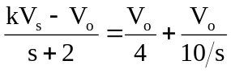
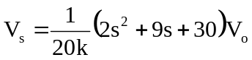

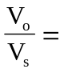10k/(s²+4.5s+15)

